Practical No. 20
Aim : WAP to generate key event and generate message: “Key pressed”
Name : Danish Altaf Solkar | Class : CO - B
Enrolment no. : 24111590805 | Batch : 2

Code :-
import java.awt.event.KeyEvent;
import java.awt.event.KeyListener;
import javax.swing.JFrame;
import javax.swing.JLabel;
public class KeyEventExample extends JFrame implements KeyListener {
private JLabel label;
public KeyEventExample() {
label = new JLabel("Press any key");
add(label);
setSize(300, 200);
setDefaultCloseOperation(JFrame.EXIT_ON_CLOSE);
setVisible(true);
addKeyListener(this);
}
@Override
public void keyPressed(KeyEvent e) {
label.setText("Key Pressed");
}
@Override
public void keyReleased(KeyEvent e) {
}
@Override
public void keyTyped(KeyEvent e) {
}
public static void main(String[] args) {
new KeyEventExample();
}
}

OUTPUT :-
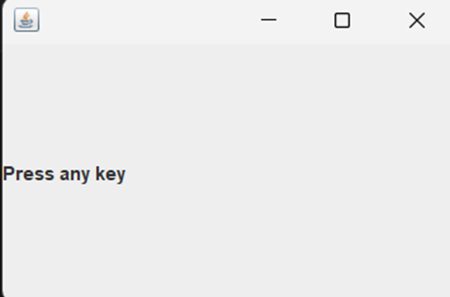
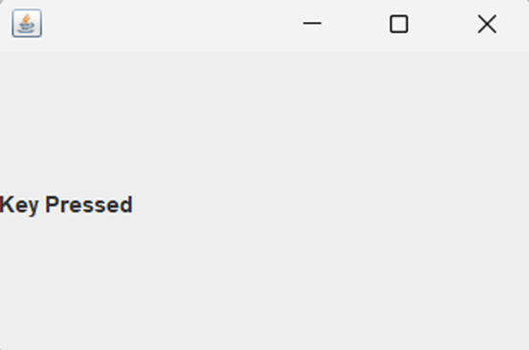

Aim : 4) WAP to demonstrate the use of mouseDragged and mouseMoved method of MouseMotionListener.
Code :-
import java.awt.*;
import java.awt.event.*;
class mouselistenerExample extends Frame implements MouseMotionListener
{
Label l=new Label("");
mouselistenerExample()
{
addMouseMotionListener(this);
setSize(600,600);
setVisible(true);
setLayout(new FlowLayout());
add(l);

}
public void mouseMoved(MouseEvent e)
{
l.setText("Mouse Moved");

}
public void mouseDragged(MouseEvent e)
{
l.setText("Mouse Dragged");
}
public static void main(String args[])
{
new mouselistenerExample();
}
}

OUTPUT :-
